Need help to identify this front hub and locate all internals thanks. I think it's 1917 to 1919 but not sure

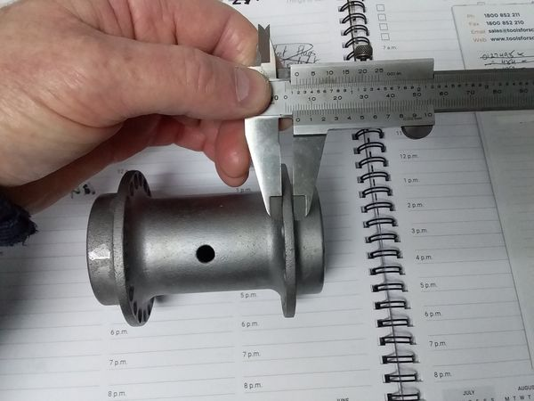

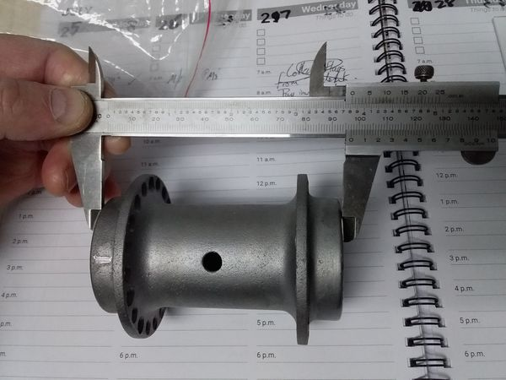

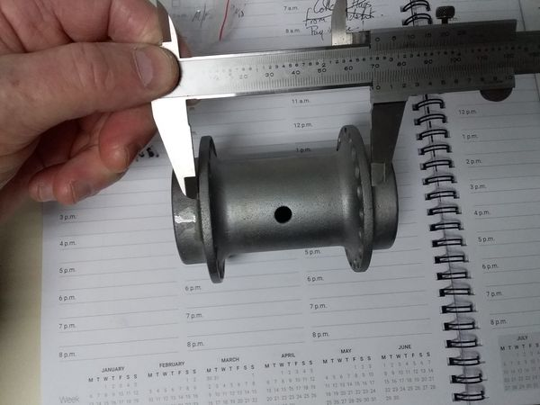

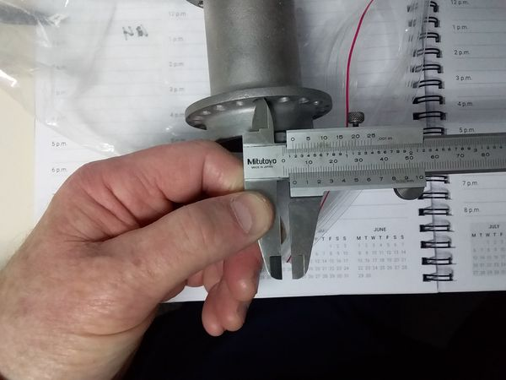

William Gilbert
Scroll down in this link. Lots of pix and names/numbers. https://www.97330.com/Bills_1923_Harley/index.html
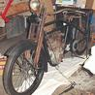
97330.COM
23JDCA 808 rebuilding
Tyrone Mustey
Thanks for the info, now I can find the internals.

Tyrone Mustey Those internals won't fit your hub.
Timothy Gottier
These are the correct internals. The 3920-21K rebuild kit from Competition would work if you fashioned some spacers that seal the internals. The bearing cones and axle bushing (spool) will fit, but the '21 and later inner and outer dust shields won't work with your hub. Robert Luland has the correct outer nuts.
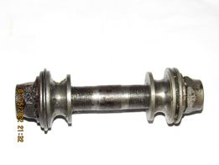
Timothy Gottier
Note the '21 and up setup uses thinner cones and nuts to work with the wider hub. The earlier sealing rings were replaced by inner and outer dust shields. If you use the later cones and earlier wide nuts, you will have to fabricate some kind of spacer/seal to make up the difference.
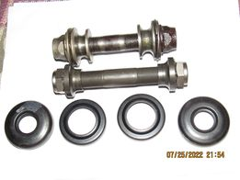

Timothy Gottier thanks for the info, much appreciated. Think I will use the 3920-21K and machine some spacers to suit.
Tyrone Mustey This should give you the needed dimensions. If you are trying to keep it original looking, you can machine the flats in the spacer and extend the lock pin. A 36x42x6 seal or cork washer could be fitted between the hub and the cone. Sor…
